**DECIMAL TO HEXA DECIMAL**:

#include<stdio.h>  
  
  
int main() {  
  
  
 long int decimal Number, remainder, quotient;  
  
  
                int I =1,j,temp;  
  
  
     char hexa decimal Number[100];  
  
  
                print f("Enter any decimal number: ");  
  
  
                scan f("%d", & decimal Number);  
  
  
                quotient= decimal Number;  
  
  
                while(quotient!=0)  
{  
  
  
          temp= quotient % 16;  
  
  
                   //To convert integer into character  
  
  
                                if(temp < 10)  
  
  
                                           temp =temp + 48; else  
  
  
                                         temp = temp + 55;  
  
  
                                hexadecimal Number[i++]=temp;  
  
  
                                quotient= quotient / 16;  
  
  
                }  
  
  
                print f("Equivalent hexadecimal value of decimal number %d: ",decimal Number);  
  
  
                for (j = i -1 ;j> 0;j--)  
  
  
                       
print f("%c", hexa decimal Number[j]);  
  
  
                return 0;  
  
  
}

**INPUT:**

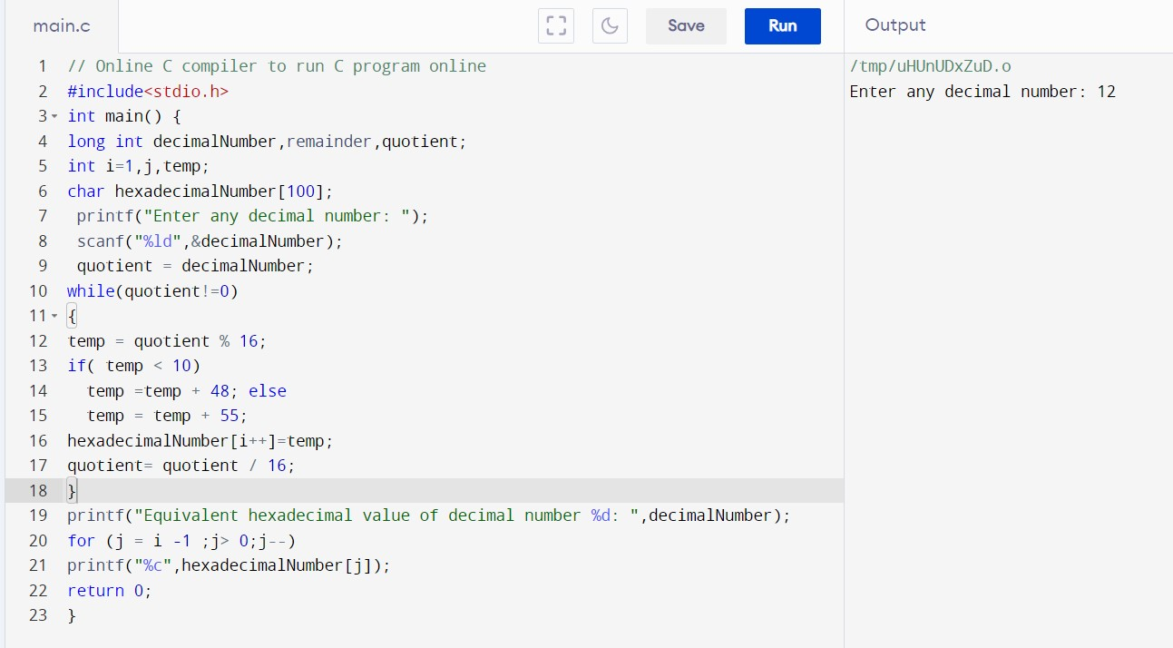

**OUTPUT :**

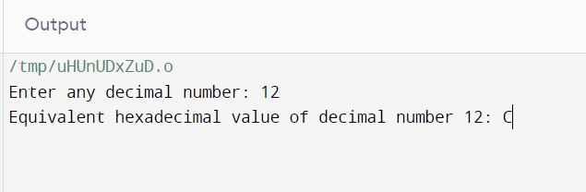

**RESULT:**Thus the program was executed successfully using Dev C++.